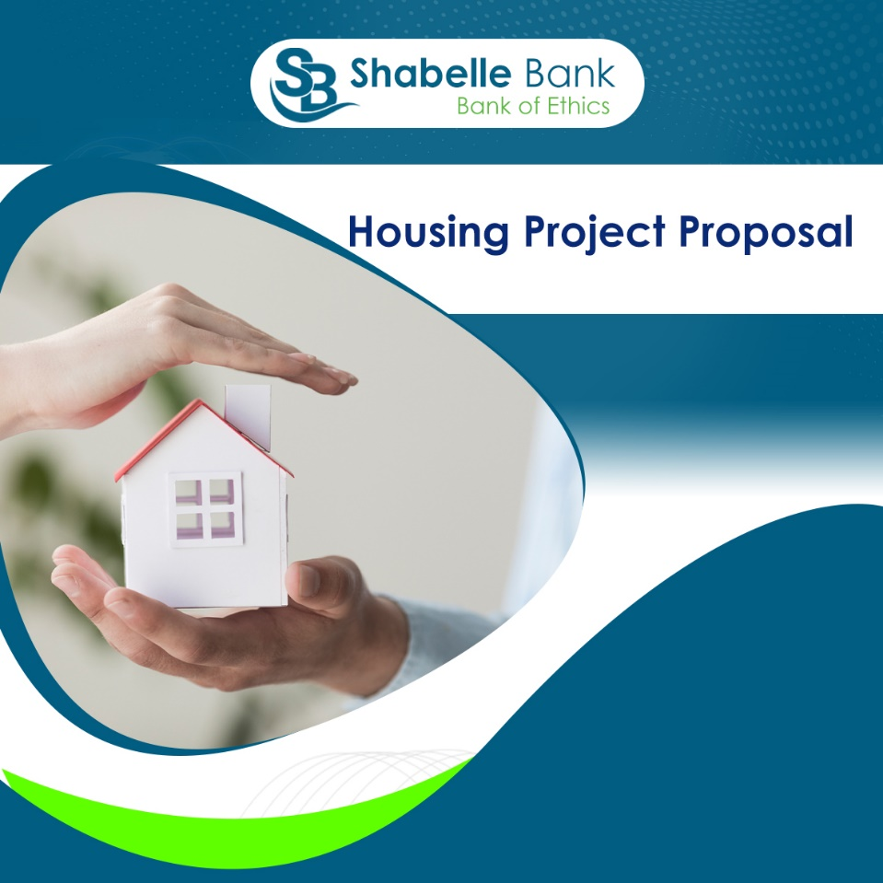
1. Executive Summary

The housing sector in Jigjiga as well as the other towns of Somali Regional State is rapidly growing, with an increasing demand for affordable and quality housing. Shabelle Bank is proposing a unique housing project that aims to cater to the needs of customers who are eager to own homes but lack the full upfront capital. This proposal outlines the bank’s plan to offer a housing package where customers can deposit 50% of the house price, and Shabelle Bank will take responsibility for constructing the house. The housing options include 3-room, 5-room, and 7-room houses, catering to different customer segments.

Ethiopia, like many other developing nations, is grappling with a serious housing shortage, especially in its rapidly urbanizing cities. This massive shortfall has dire implications for the quality of life, economic growth, and overall development of the nation.

Shabelle Bank's Solution

Recognizing the urgency of the housing crisis in Jigjiga, Shabelle Bank is introducing a housing project aimed at empowering customers to own homes through a structured and affordable payment plan. The project is designed to address the needs of low- and middle-income residents by providing a practical solution to the housing shortage.

Through this initiative, customers will be able to secure their homes by depositing 50% of the house price into a specially designed account at Shabelle Bank. Once the deposit is made, the bank will facilitate the construction of the customer's home, offering a pathway to home-ownership that is both accessible and affordable. This model not only helps individuals achieve their dream of owning a home but also contributes to alleviating the city’s housing deficit by promoting sustainable housing development.

Shabelle Bank’s housing initiative is a testament to our commitment to improving the lives of our customers and addressing the pressing social and economic challenges they face. By providing affordable housing solutions, we aim to enhance the overall living conditions of Jigjiga’s residents and contribute to the long-term development of the city.

3. Market Analysis

3.1. Housing Demand in Jigjiga

Jigjiga has seen a steady population increase, leading to a high demand for housing. The current housing market is characterized by a shortage of affordable homes, pushing many residents to seek alternative solutions. Shabelle Bank's housing project is designed to meet this demand by offering accessible and customizable housing options.

3.2. Customer Demographics

The target market for this project includes Diaspora, middle-income earners, young professionals, newlyweds, and families looking for affordable housing solutions. These customers are often employed, have a steady income, and are keen on home-ownership but may lack the full financial resources needed for an outright purchase.

4. Project Objectives

The primary objectives of the housing project are:
- To provide affordable housing solutions to the residents of Jigjiga.
- To increase Shabelle Bank's customer base by offering attractive financial products.
- To support the growth of the local economy by investing in the construction sector.
- To build lasting relationships with customers through value-added services.

5. Project Structure

5.1. Housing Packages

Shabelle Bank recognizes the urgent need for affordable housing and is committed to providing practical, accessible solutions for residents. To address this growing demand, and it is introducing a comprehensive housing initiative with three distinct options designed to cater to different customer needs. This proposal outlines three tailored solutions aimed at enabling residents to achieve homeownership in Jigjiga.

Option 1: Land + Building
This option is designed for customers who do not yet own land but wish to purchase a home. Shabelle Bank will secure the land and construct the house on behalf of the customer. The Land + Building package offers flexibility and customization, allowing customers to choose from three subcategories of villas, each designed to meet various preferences and financial capabilities.
Shabelle Bank is offering three types of housing packages:
- Kaaftoon Villas:
This is the first type of villa, occupying a land area of 250m², and featuring 3 rooms: (one master bedroom, one standard bedroom, and a salon room). Additionally, it includes a toilet, a kitchen, parking space, and a fenced yard.
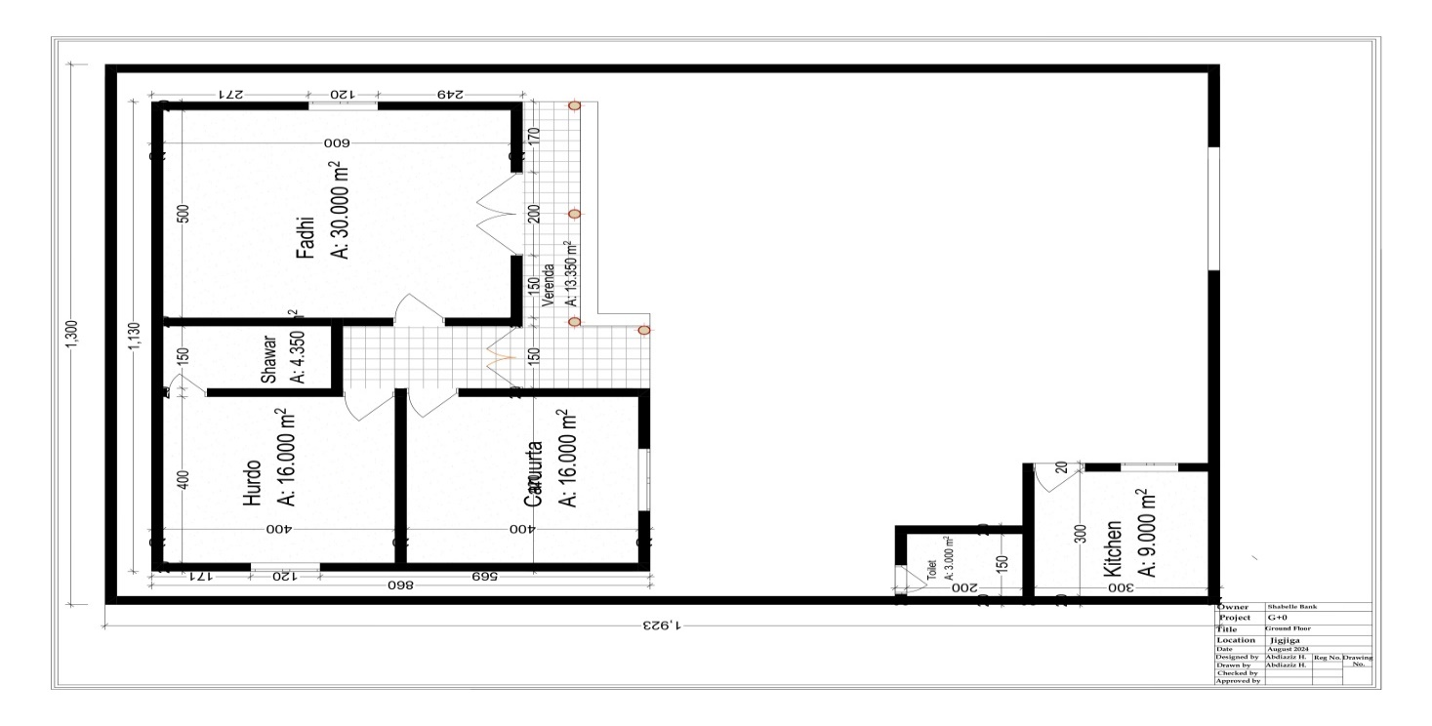
It offers a practical and economical solution for customers with limited budgets. This option provides functional and well-planned homes that meet basic housing needs at an affordable price for first-time homeowners or those looking to own a home with minimal financial strain.

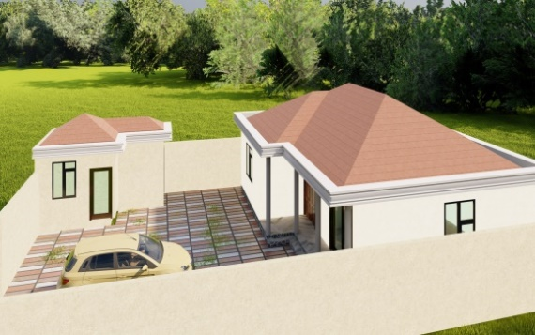
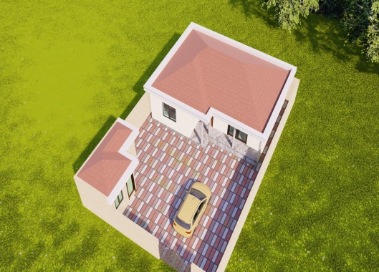

- Kifaaya Villas:

This option represents a more affordable, yet well-designed housing solution for middle-income customers. These villas maintain a balance between cost-effectiveness and quality, providing comfortable living spaces without compromising on essential features.
It is occupying a land area of 300m², and featuring 5 rooms: (One master bedroom, two standard bedrooms, and a salon room, additionally, it includes a service room), a kitchen, a toilet, parking space, and a fenced yard. These Villas are ideal for those who desire a modern home at a moderate price.
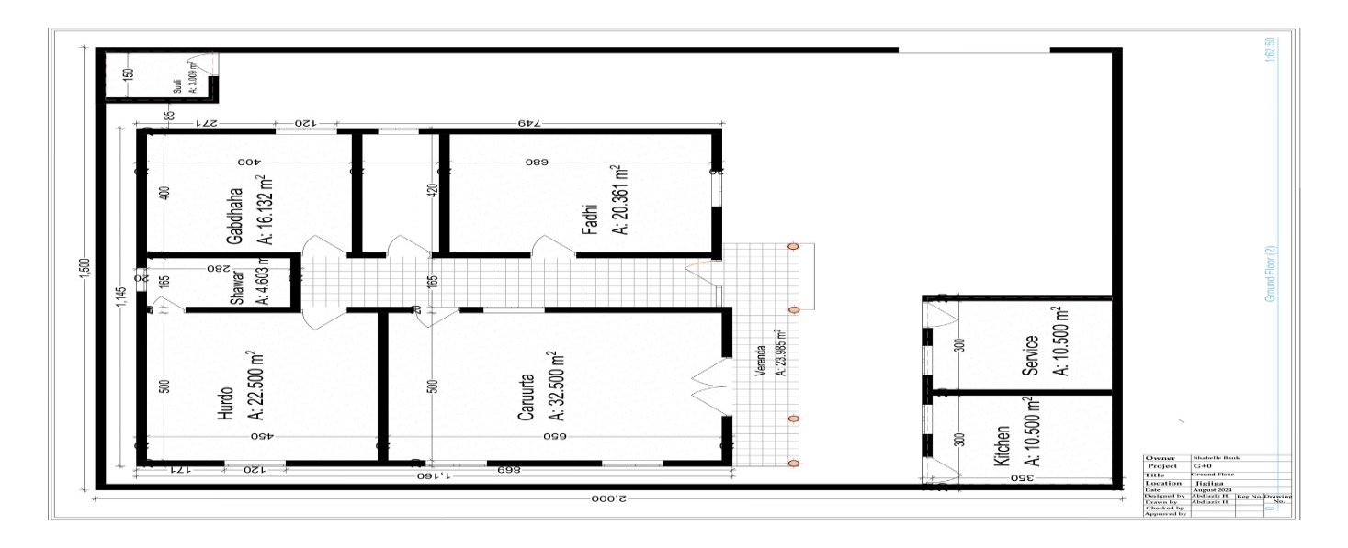
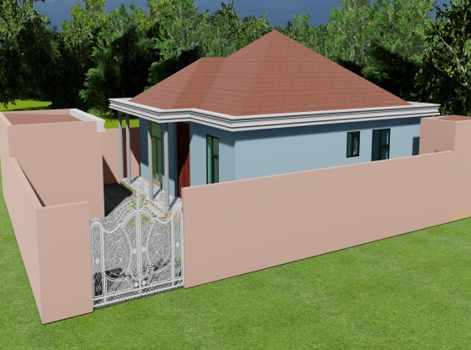

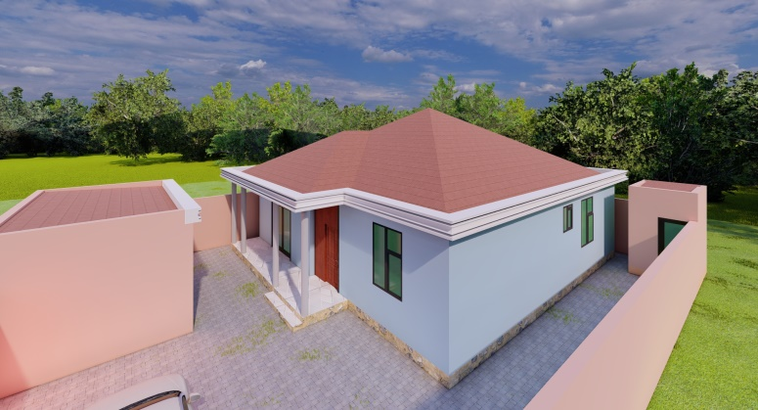

- Maan-Kaab Villas:

This is the premium option, offering spacious homes with modern designs and luxury features. These villas are ideal for customers seeking high-end homes with ample living space, high-quality materials, and superior finishes.

It is occupying a land area of 400m², and featuring 7 rooms: (One master bedroom, three standard bedrooms, and a salon room. Additionally, it includes two service rooms), a kitchen, a toilet, parking space, and a fenced yard. It is designed for large families, seeking more luxurious accommodations.

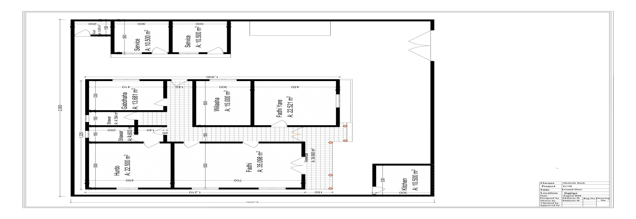

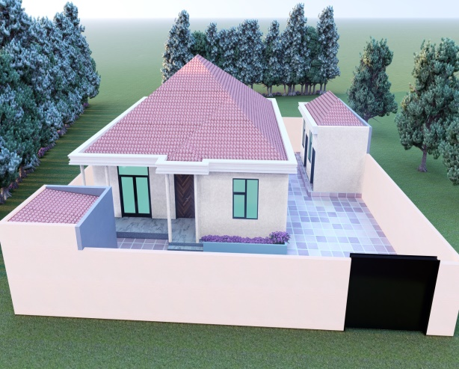
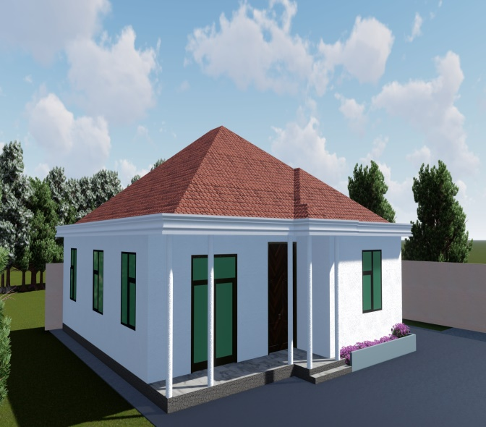

Option 2: Building Only

The Building Only option is tailored for customers who already own land but require assistance with constructing their homes. Shabelle Bank offers construction services for one of the three villa models: Kaaftoon, Kifaaya, or Maan-kaab. This option allows customers to customize their homes while benefiting from Shabelle Bank’s expertise in construction and project management.
Customers who select the Building Only option will be able to choose a villa type that aligns with their financial capacity and desired level of customization. Shabelle Bank will manage the construction from start to finish, ensuring that the project is completed on time and within budget.

This option, presents a significant market opportunity for Shabelle Bank. This option targets a growing demand in Jigjiga, particularly in marketable areas where customers already own land but lack the financial capacity to rebuild after their properties were demolished. The demolitions have largely occurred due to the city’s beautification projects or the new Jigjiga Corridor Program, which aims to modernize and enhance the aesthetic and functional appeal of the main roads and city layout.
By capitalizing on this demand, the bank not only supports local development but also strengthens its presence in the community as a key player in Jigjiga’s urban transformation. This initiative will help landowners realize their rebuilding goals while offering Shabelle Bank a profitable venture that aligns with both social and economic development objectives.

Option 3: Finishing
For customers who have already started constructing their homes but need financial and technical support to complete the project, Shabelle Bank offers the Finishing option. This service is designed to assist homeowners in finalizing construction, allowing them to move into their homes without further delays.
Whether the customer needs assistance with interior work, roofing, painting, or general finishing touches, Shabelle Bank’s Finishing service provides expert guidance and financial support. This option ensures that the customer’s home is completed to a high standard, without exceeding the original budget.

Summary of Finishing Benefits
- Enables customers to complete their homes with professional assistance from Shabelle Bank.
- Covers final stages of construction, including interior and exterior finishes.
- Flexible financing options tailored to the customer’s specific needs.

5.2. Pricing and Payment Plans
- Pricing
S/n | House type | Estimated price | Comment
1 | Kaaftoon Villas: | 6,900,000
2 | Kifaaya Villas | 8,950,000
3 | Maan-Kaab Villas | 10,500,000

- Payments: Customers are required to deposit 50% of the house price into a designated account. The pricing for each housing type will be based on current market rates and construction costs. The remaining 50% will be financed through a Sharia-compliant mortgage plan, which can be repaid over a fixed period.

Eligibility Criteria

To qualify for the housing project, customers must:
- Open a special housing account with Shabelle Bank.
- Deposit 50% of the house price into the account.
- Provide proof of income and other necessary documentation to ensure they can meet the repayment requirements.
- Application letter
- Proof of Identity (ID, Passport, etc.) of the applicant and mortgagers
- Trade registration certificate
- VAT certificate
- Marriage Certificate or otherwise of the applicant and the mortgager
- Financial statements / at least for 3 yrs./ (for requests above 5 million Audited, and for less than 5 million Provisional)
- Interim financial statement for recent months
7. Financial Plan

7.1. Cost Estimation

For the financial plan of Shabelle Bank's Jigjiga housing project, we will outline the estimated costs and details for the 1st phase of building 20 villas with different options. The plan includes key components such as land acquisition, construction materials, labor, and administrative expenses.
This total includes land acquisition, construction, labor, and administrative expenses for all 20 villas in the 1st phase. The next phase can scale up based on customer demand and available resources.
S.n | House | Qtty | U. price | T. Price | Comment
1 | Kaaftoon (complete) | 3 | 6,900,000 | 20,700,000
2 | Kifaaya (complete) | 2 | 8,950,000 | 17,900,000
3 | Man-kab (complete) | 1 | 10,500,000 | 10,500,000
4 | Kaaftoon (Building only) | 3 | 4,500,000 | 13,500,000
5 | Kifaaya (Building only) | 3 | 6,500,000 | 19,500,000
6 | Man-kab (Building only) | 1 | 8,000,000 | 8,000,000
7 | Finishing (Only) | 7 | 2,500,000 | 17,500,000
 | Total | 20 |  | 107,600,000

7.2. Funding and Financing

Shabelle Bank will finance 50% of the project costs through customer deposits and the remaining 50% through a Murabaha financing model.
10. Conclusion and Recommendations

The housing project proposed by Shabelle Bank presents a unique opportunity to address the housing needs of Jigjiga’s residents while expanding the bank’s portfolio. By offering affordable and customizable housing solutions, Shabelle Bank will strengthen its position in the market and contribute to the socio-economic development of the region. It is recommended that the project be launched with a strong marketing campaign and a clear focus on customer satisfaction to ensure its success.

