

***Subject: Proposal for the Introduction of Foreign Currency Accounts***

***Introduction***

As Shabelle Bank continues to expand its portfolio and meet the evolving financial needs of our diverse clientele, the introduction of a Hard-Currency Account product line is a strategic move aimed at tapping into a growing segment of customers. This includes individuals working with international organizations, business communities engaged in cross-border trade, NGOs, and entities receiving funds from abroad. These customers are increasingly seeking reliable and secure banking services to manage their foreign currency inflows.

In response to this demand, we propose launching three Hard-Currency Account products: (Current Account, Savings Account, and Time Deposit Account). These products are designed to cater to various customer needs, from day-to-day transactions to long-term savings and investment options in foreign currencies. Our goal is to mobilize $5 Million in deposits during the first year (2024/25), positioning Shabelle Bank as a trusted partner for clients handling international financial operations.

***Objective***

The key objectives of proposing the Hard-Currency Account products at Shabelle Bank are as follows:

1. Expand Customer Base: Attract and retain customers who receive income in foreign currencies, including individuals working in international organizations, NGOs, and business communities engaged in cross-border trade.
2. Enhance Deposit Mobilization: Mobilize $5 million in hard-currency deposits within the first year (2024/25) through the introduction of Current, Savings, and Time Deposit accounts.
3. Increase Foreign Currency Reserves: Strengthen the bank's foreign currency reserves to support international transactions and enhance liquidity for forex-related services.
4. Diversify Product Portfolio: Expand the bank’s product offerings by introducing competitive foreign currency account options tailored to various customer needs, ensuring comprehensive financial services.
5. Support Customers' Financial Growth: Provide secure and flexible financial solutions for customers looking to save, invest, and manage their foreign currency, thus enhancing customer loyalty and satisfaction.
6. Boost Revenue Streams: Generate additional revenue through fees, forex transactions, and mark-ups on hard-currency investment, contributing to the overall profitability of the bank.

***Proposed FCY Products***

We propose the following types of Foreign Currency Accounts:

1. **Current** **Account (AMIIN CURRENT ACCOUNT)**

 This account is specifically designed to meet the needs of customers (individuals and organizations) who want to manage their day-to-day transactions in foreign currency by cheque

The contract is structured using the Qard principle, which means the bank is liable to pay the depositor's money back on demand, while the bank can use these funds for investment and other purposes. It provides the satisfaction of having money safely deposited with a bank, along with the assurance that the bank is not investing it in activities that contravene Shariah principles.

Free services are offered to all customers, meaning that all free services are available to both current and savings account holders.

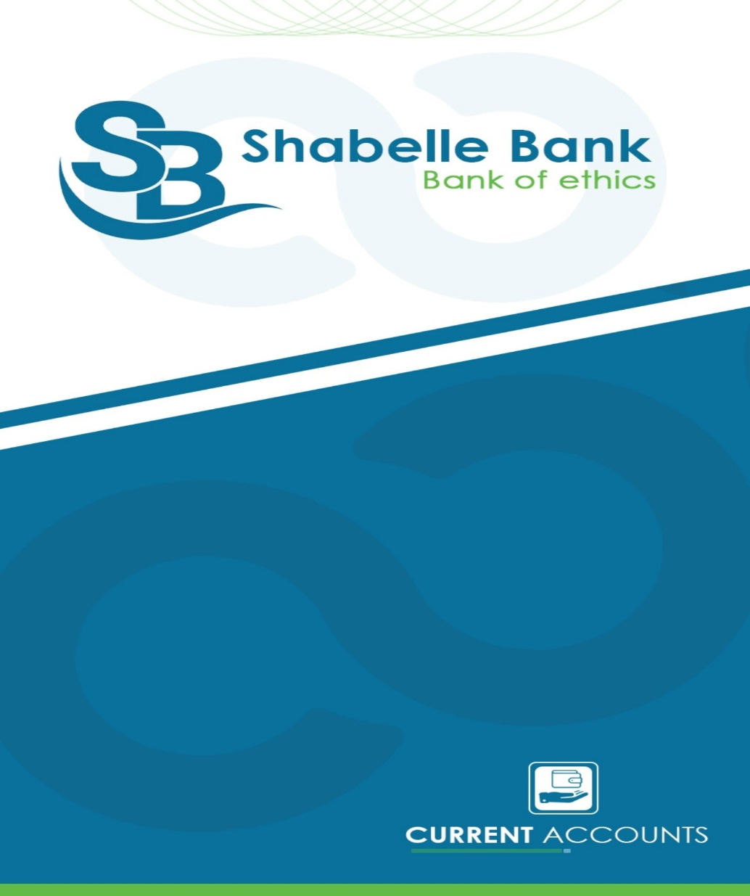

***2. Saving Account (Dhitaysi Saving Account)***

The savings account is the same as current Account in everything but the only different is that the saving account can be used without cheque; and its contract is based on the “Amana/Qard” principal, which means the bank is liable to pay the depositor's money back on demand, while the bank can use these funds for investment and other purposes. It provides the satisfaction of having money safely deposited with a bank, along with the assurance that the bank is not investing it in activities that contravene Shariah principles.

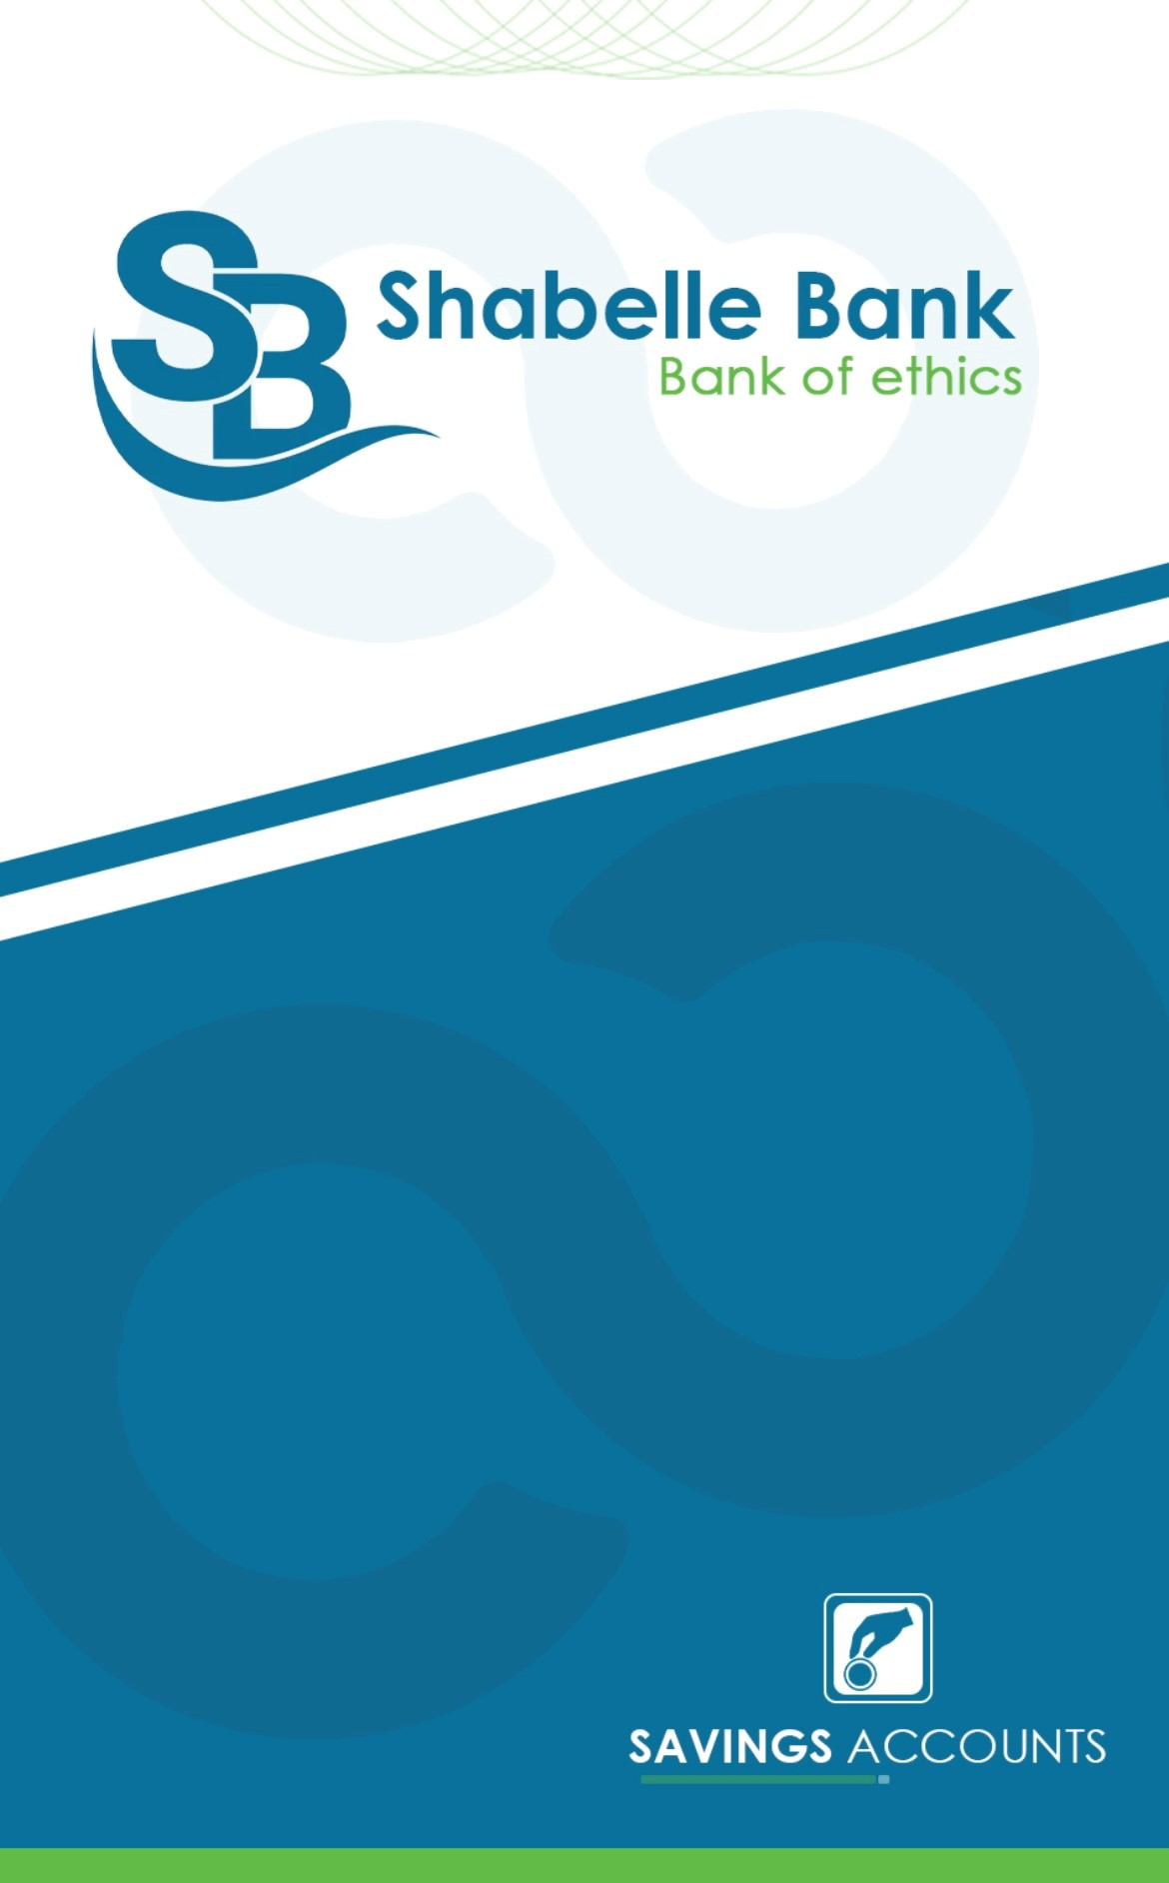

3. **Saving Investment Acc/Time Deposit Account**

This is an investment account in which represents the case when the owner of funds seeks a return on their funds and are willing to spare these funds for an agreed period, The client provides a minimum deposit of USD 1,000, and Shabelle Bank accepts, manages and invests the funds on Islamic Mudaraba basis aiming at realizing the best profit for the mutual

interest of the parties. The terms of deposit are six months, one year, 3 years and 5 years.

***Features and benefits for the client***

* Time Deposits are available in different major currencies such as (USD, Euro, SAR and GBP)
* Option to select the duration (6 months, 1 year, 3 years or 5 years)
* Returns are Shari’a-compliant
* Returns distributed at the end of the period if it’s one year and less, and annually if its more than a year.
* Deposit is automatically renewed unless instructed otherwise
* No fees on locking deposit and it remains at disposal

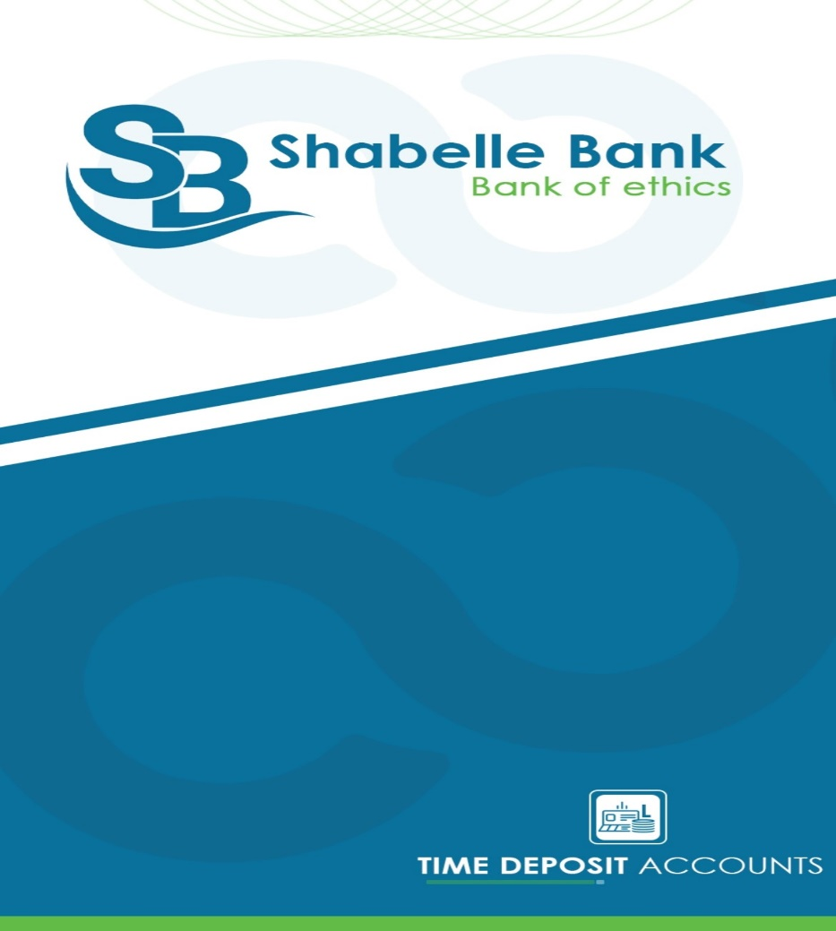

***Eligibility Criteria***

The following individuals and organizations will be eligible to open FCY accounts:

1. Residents of Ethiopia (Individuals and non-profit organizations) for receiving foreign funds.
2. Non-Resident Ethiopian Individuals (Ethiopian citizens living abroad).
3. Persons of Ethiopian Origin (Non-resident foreign nationals of Ethiopian origin)

***Conclusion***

In conclusion, the introduction of Hard-Currency Accounts at Shabelle Bank represents a significant opportunity to meet the growing demand for foreign currency banking services among our target customers, including international workers, NGOs, and businesses with global financial engagements. By launching these Accounts, we aim to mobilize $5 million in deposits within the first year (2024/25), solidifying our position as a trusted financial partner in Ethiopia’s international banking landscape.

These products not only enhance our foreign currency reserves but also diversify our offerings, driving both customer satisfaction and profitability. With a clear strategy and an understanding of market needs, Shabelle Bank is well-positioned to capitalize on this initiative, fostering stronger customer relationships and ensuring sustainable growth in the competitive financial sector.